1. Use the spreadsheet your teacher has given to you to create the designs below.

|  |  |  |  |  |  |  |  |
| --- | --- | --- | --- | --- | --- | --- | --- |
| 128 | 64 | 32 | 16 | 8 | 4 | 2 | 1 |
|  |  |  |  |  |  |  |  |

128 + 32 + 16 + 8 + 1 = **185**

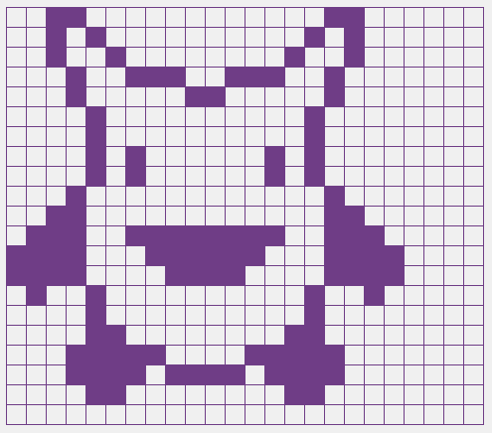 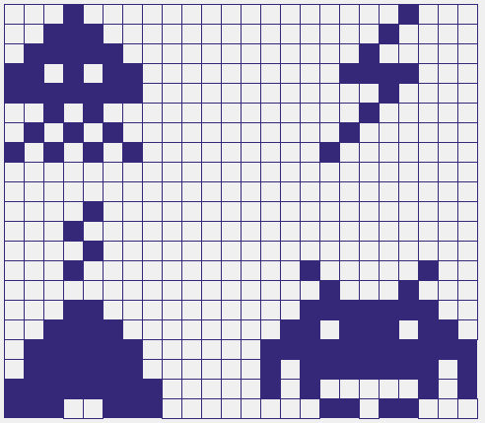

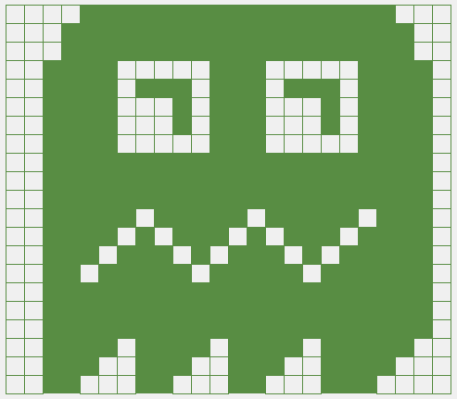 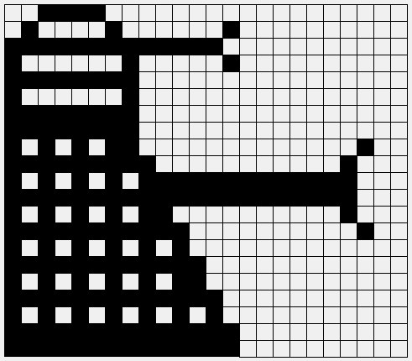



1. Now try to create
   1. Pacman
   2. Snoopy
   3. Flying Saucer
   4. Alien
2. 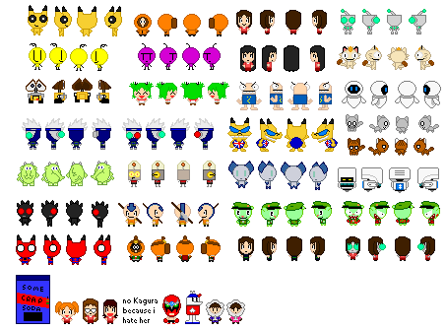Now make some designs of your own.